Online Practice

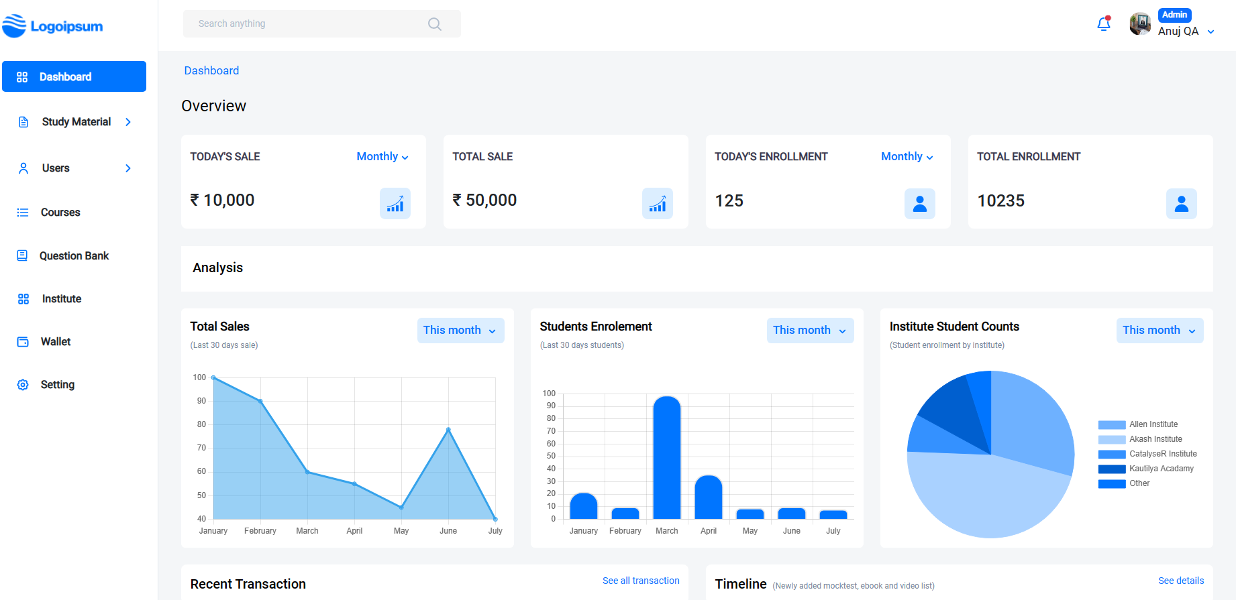

This Platform is design for students, who prepare for Academic (CBSE, MPBoard) , Entrance exams (IIT-JEE, NEET) and Government Recruitment exams (Bank PO, SSC, Railways).

**Key Points**: -

(i) Students from different institute directly register to this website.

(ii) Registration based on their institute code or direct through credentials.

(iii) After registration student can prepare for exam according to their interest.

(iv) Student is able to give mock test and go through Previous Year Paper (Purchase from wallet.)

Basic Five Modules are available to them: -

**(A) Mock test: -** Mock test basically a revision test, which provide a practice test to student and result will be generated according to their performance.

(B) **E-book: -** E-book module has all PDF format book available for different subjects.

**(C) Previous Year Paper: -**This module has collection of previous year paper and student can buy it from wallet.

**(D) Videos: -** This module has videos for different subject and topics.

(E) **Live Classes: -**It will be future scope for student that they can attained live classes.

This project has three Role based modes.

**(1) Admin**: - Admin has all access and permission

• Admin able to create edit and delete staff.

• Admin can add multiple staff in different institute and give them permission according to module wise (ex: - E-book, videos)

• Admin can create a new Exams, Courses, Sub Courses, Subject, Topic and Subtopic.

• Admin can create a new institute.

• Admin has all module permission (Question Bank, Institute, Previous Year paper, Live Classes, Videos, E-book, Mock test)

• Admin can resend password for staff.

• Admin can see student performance regarding the mock test given by them.

**(2) Staff**: - Here staff role considers as a member who assigned by admin.

• Staff can add questions In Question bank.

• Staff can create mock test, videos, add E-Book.

• Staff can add previous year paper.

• Staff can edit and delete data which is added by him.

**(3) Student**: - Student is register through the credentials provide by institute.

• Student can give mock test for different subjects.

• On behalf of mock test, they can see their rank and result analysis.

• Student can purchase previous year paper.

• Student can see videos for different topic and subject.

• Student can purchase E-book using wallet.

• Student can attain live classes. (Future scope)

• Student can recharge their wallet through different modes of online payment.

Project Technical Details

(I) Using .NET Core 6.0 as Backend

(II) APIs are authorized by token.

(III) React as frontend/ React Native as Mobile web.

(IV) SQL as database.

(V) Repository pattern is used.

(VI) Using Serilog for logs.

(VII) Using fluent validation for validations.

(VIII) Razor Pay integration. (Future scope)